**IDB Lab-4**

**Create Table**

1. Create table Student(student_id varchar(20), student_name varchar(30),  
   marks number, grade varchar(2));

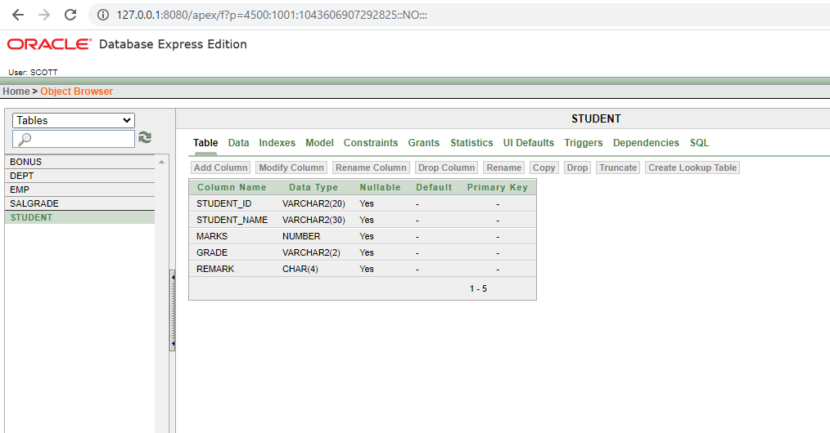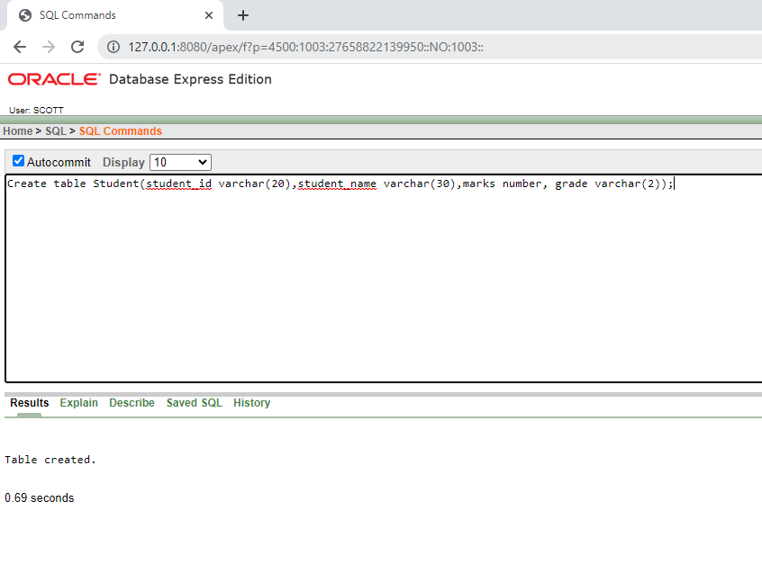

**Some Example of insert Data**

1. insert into student values ('GA-001', 'Jhon', 285, 'A', 'Pass');

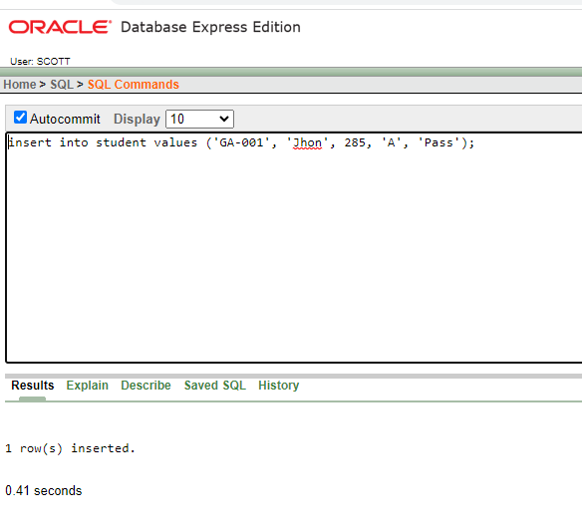

1. insert into student values ('GA-002', 'Robert', 247, 'B', 'Pass');

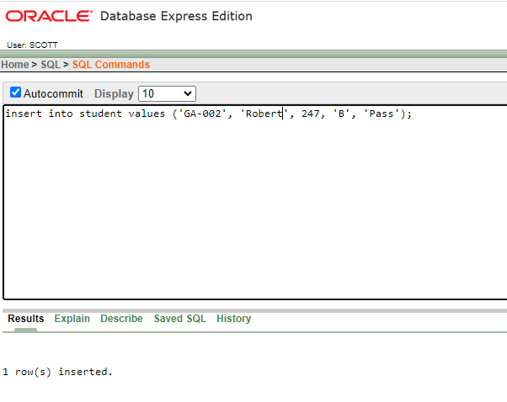

**All Insert Data**

1. insert into student values ('GA-001', 'Jhon', 285, 'A', 'Pass');
2. insert into student values ('GA-002', 'Robert', 247, 'B', 'Pass');
3. insert into student values ('GA-003', 'Emma', 329, 'A+', 'Pass');
4. insert into student values ('GA-004', 'Ayon', 249, 'B', 'Pass');
5. insert into student values ('GA-005', ‘Niloy', 140, 'F', 'Fail');
6. insert into student values ('GA-006', 'James', 187, 'D', 'Pass');
7. insert into student values ('GA-007', 'Nidhi', 352, 'A+', 'Pass');
8. insert into student values ('GA-008', 'Noah', 279, 'B', 'Pass');
9. insert into student values ('GA-009', 'Noman', 350, 'A+', 'Pass');
10. insert into student values ('GA-010', 'Asif', 301, 'A', 'Pass');

**Select Table**

Select STUDENT_ID, STUDENT_NAME, MARKS, MARKS*.25 Percentage, GRADE, REMARK FROM student order by STUDENT_ID;

